**Visual Studio Online**

**Getting started with Visual studio online**

Here you’ll walk through the process of setting up a free Visual Studio Online account and creating a new team project. If you already have a VSO account that you would like to use for this exercise, go head and log in and then skip to the next task.

**Creating a Visual Studio Online account**

1. Navigate to <http://www.visualstudio.com/products/visual-studio-online-overview-vs> and select the “Get started for free” link.

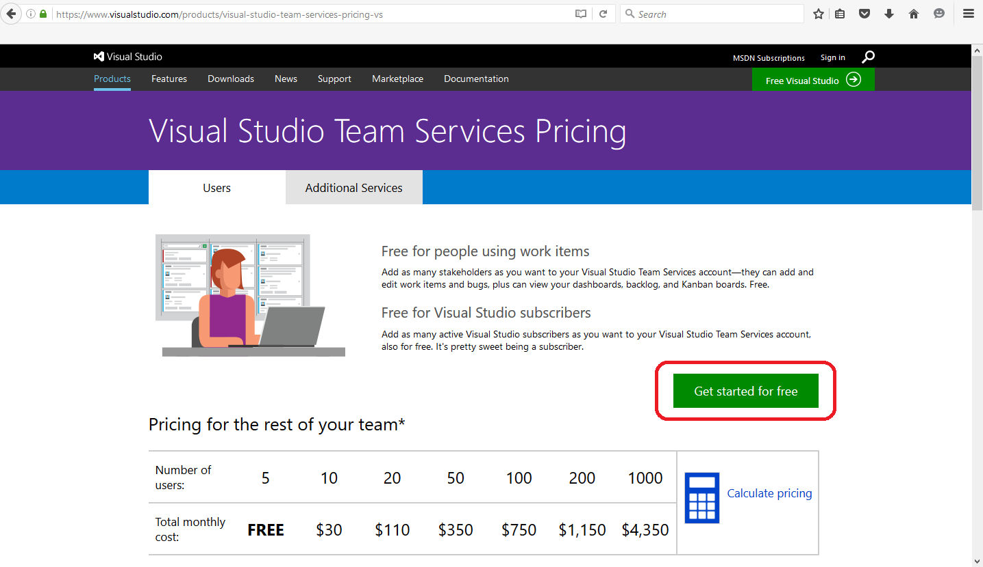

1. Log in with your Microsoft account. If you do not have one, you need to create one before moving on.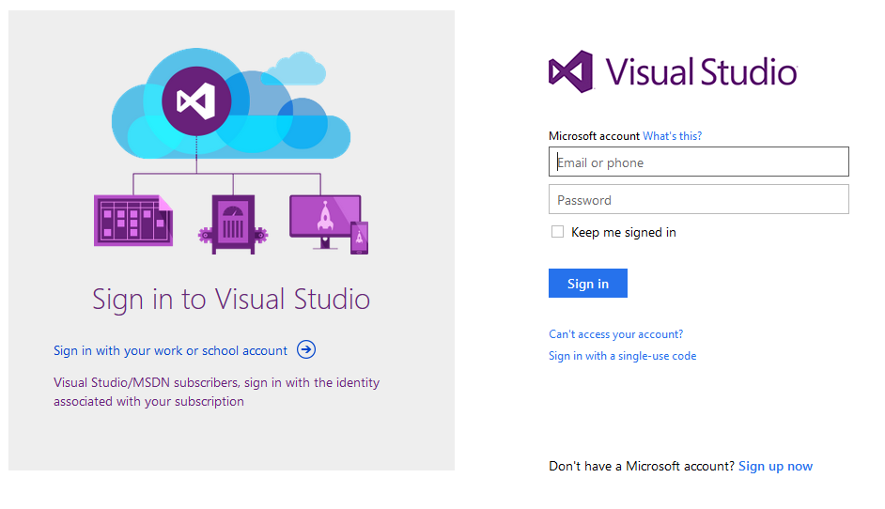
2. Provide the requested information and this may vary depending on how much information could be retrieved from you Microsoft account. Click on **Create a free account now** link.

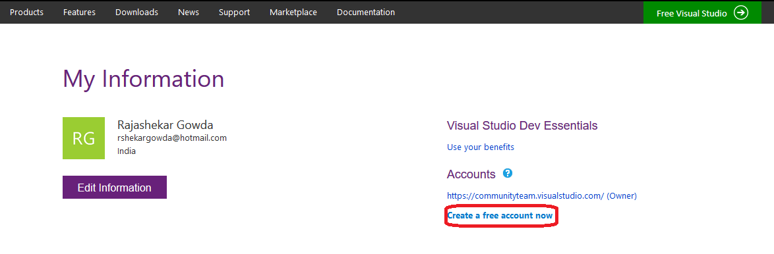

1. Next it will ask you to enter the account url that you will want your team to use to access the team environment. If you would like to change the region, then just click on **Change details.** Give some name, select region and then click on **Create account** button.

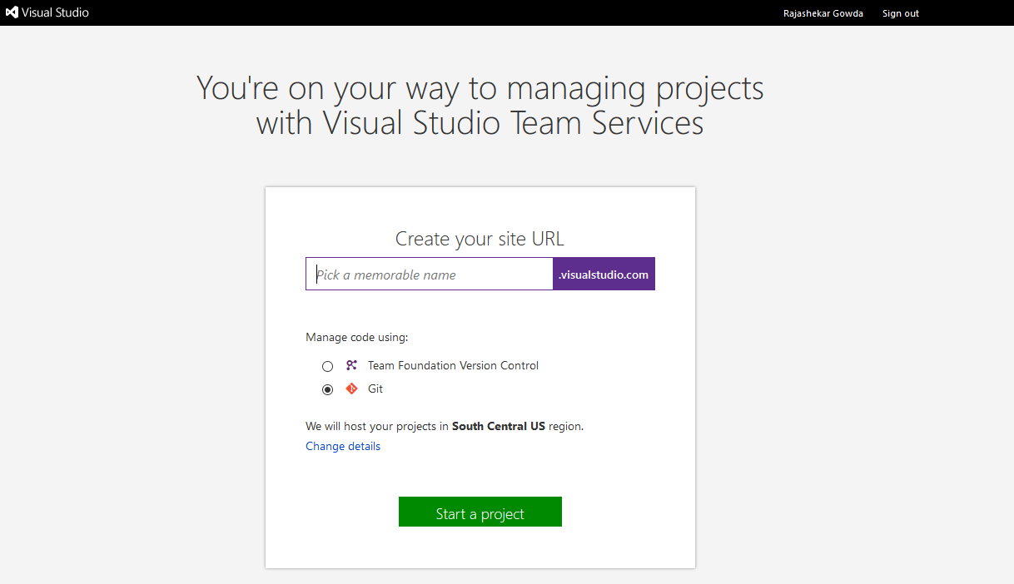

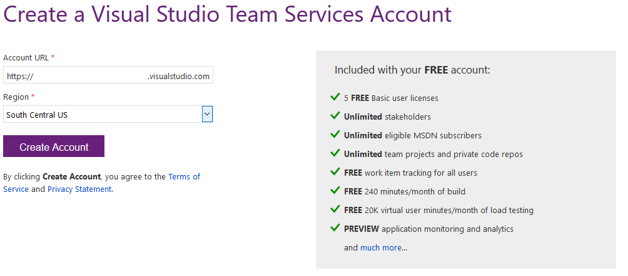

1. You should now be logged into your Visual Studio Online account.

**Starting your free trial**

1. Select the “Start Account Trial” link. This link could be located to the right of the screen as shown above or below the first box depending on your screen size.

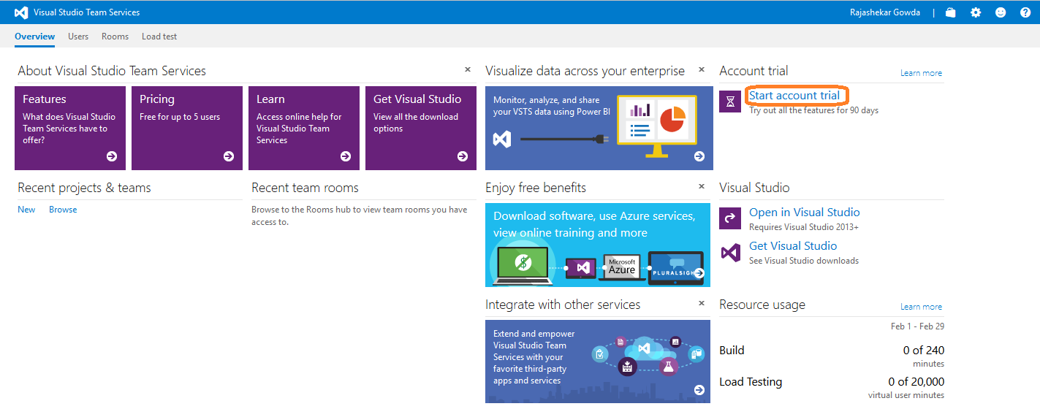

1. Click the **Begin trail** button to enable all Visual Studio Online features for 90 days.

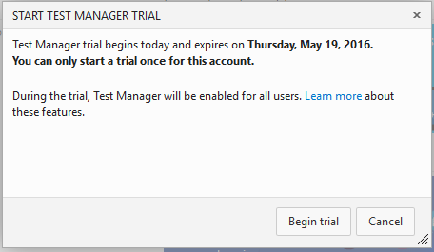

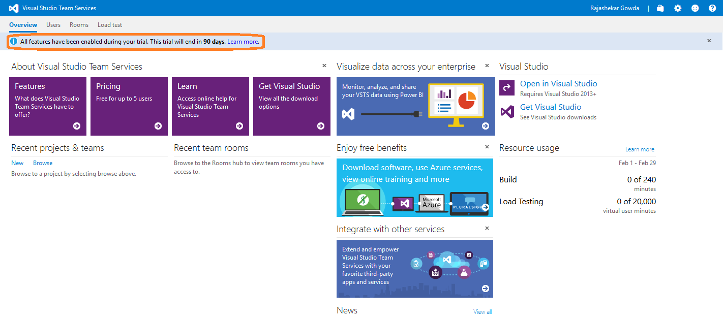

**Creating a team project**

1. Select the gear icon in the top right corner of the page to load the administrative control panel.

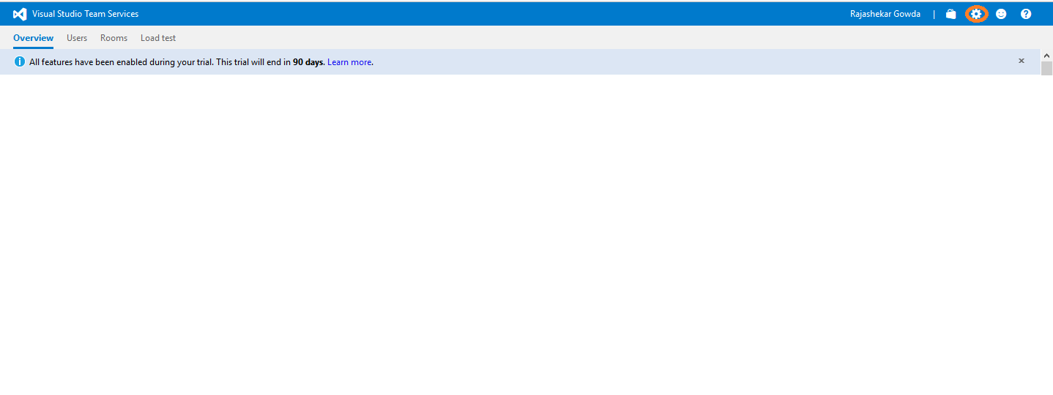

1. Ensure that you are viewing the root of the control panel (see underlined link in screenshot) and have selected the **DefaultCollection** node. Select the “Create a new team project” link.

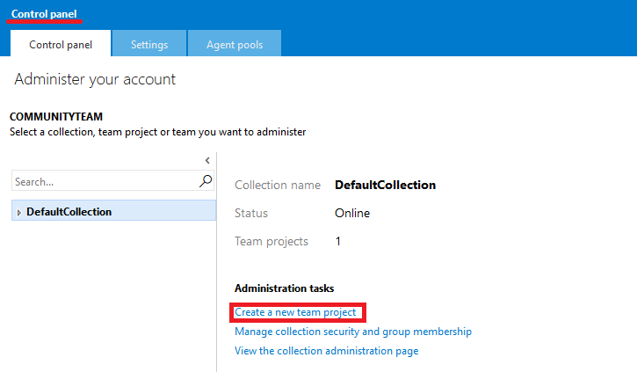

1. For the Project Name field, enter “Community Site”. Click the Create Project button to create the new project using the defaults of Team Foundation Version Control and Scrum. The focus of this lab is to introduce the team development features available with Visual Studio Online rather than the chosen methodology. The Scrum (<http://en.wikipedia.org/wiki/Scrum_(development))> methodology is just a specific implementation of an agile development process.

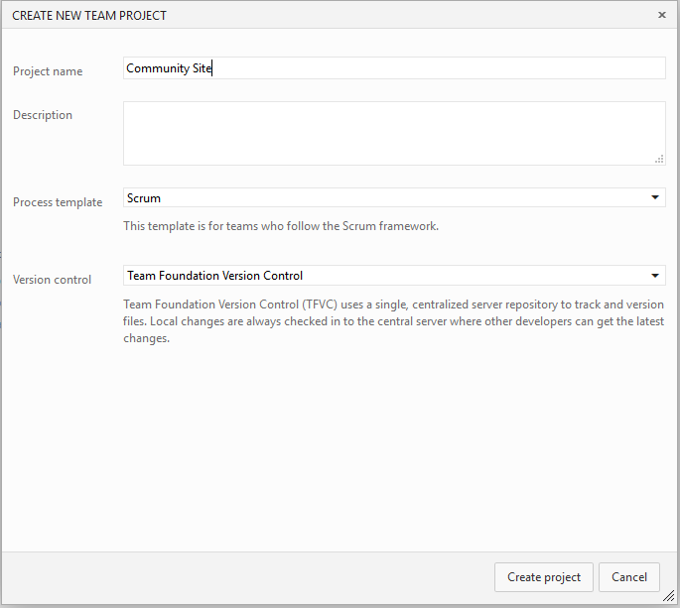

1. Once the new team project is created, click the Navigate to Project button.

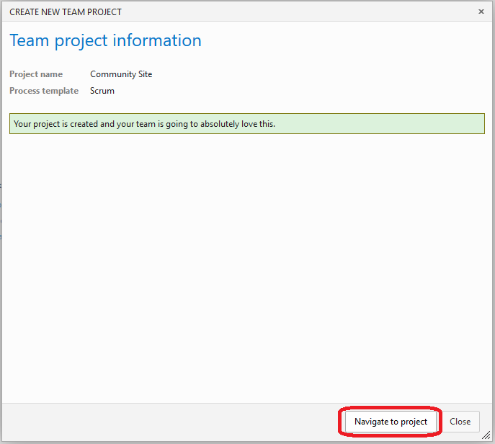

1. After navigating to the project, you should now see the default project landing page.

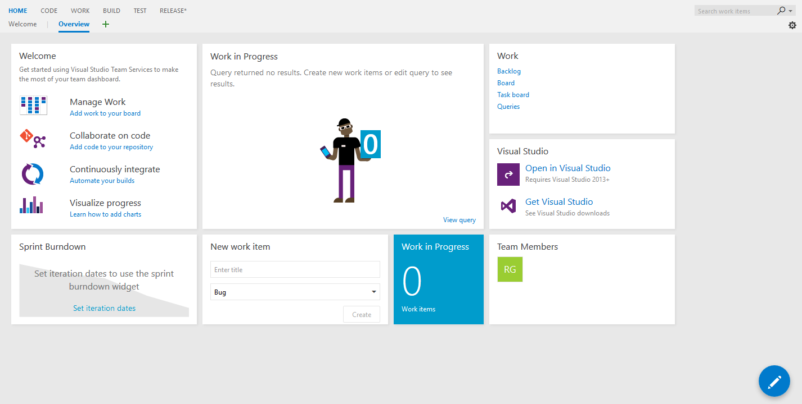

**Administration of projects, teams and permissions**

Here you will take a quick survey of project and team administration using Visual Studio Online.

**Administration of Team Members (Quick Start)**

1. Navigate to the project overview page. Click on Team Members section.

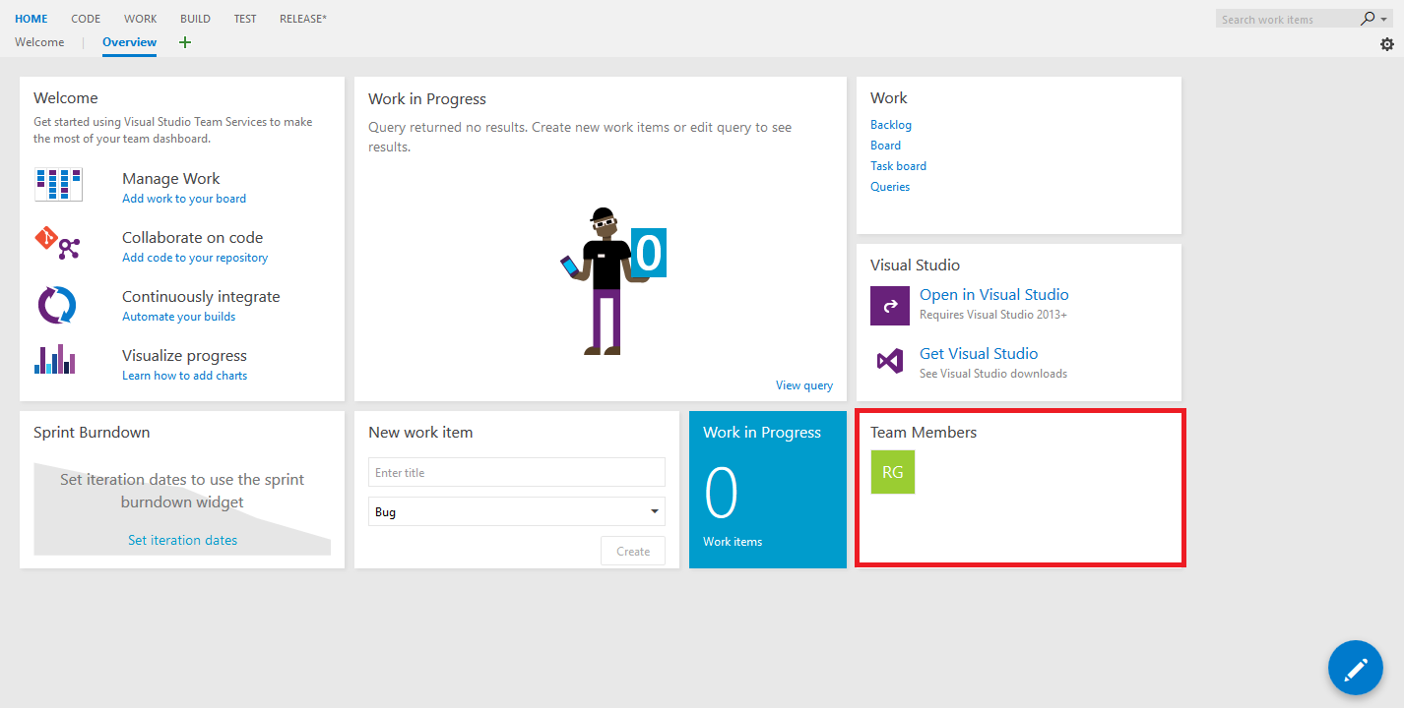

1. The **Manage Members** dialog window allows you to quickly add additional team members directly by clicking on **Add** button or by including a Visual Studio Online group. For users that have not previously connected to VSO, you can simply provide their email address and they will be added and receive a welcome message. New users will also need to create a Microsoft account if they do not currently have one.

I am not adding any additional team members here, so close the dialog windows after you are done viewing them.

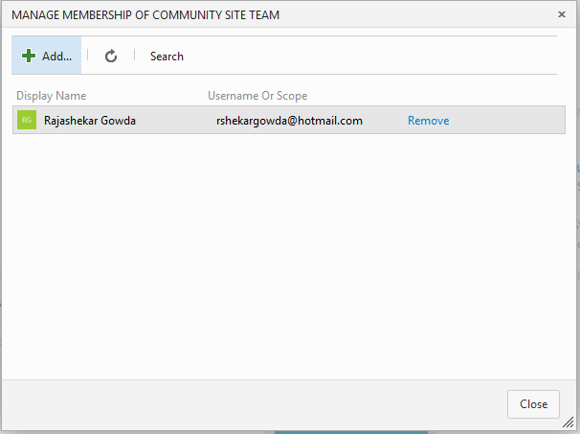

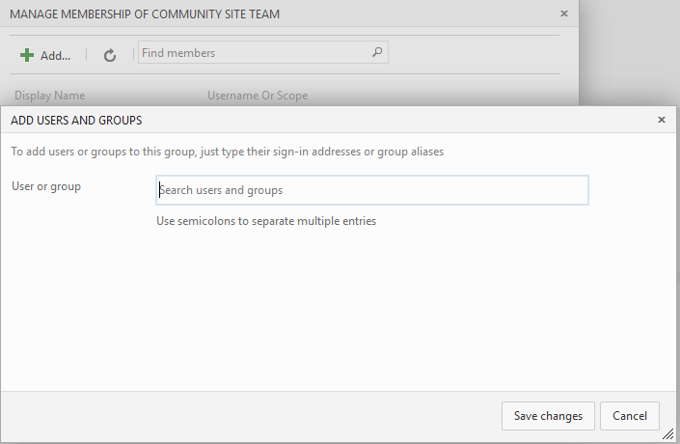

1. After adding some team members to your project, you should be able to start development using your Visual Studio Online account with the defaults that are in place, but before you get to that, you’ll survey some additional configuration and customization points available from within the VSO control panel.

**Administration of Projects, Teams, and Permissions (Administrative Control Panel)**

1. Select the **gear** icon in the top-right of Visual Studio Online to navigate to the administrative control panel. The control panel should open in a new tab.



1. There are a number of different scoping levels in the control panel that allow management of everything from the VSO account to the teams. You should now be looking at the control panel that is scoped to the new “Community Site” project.

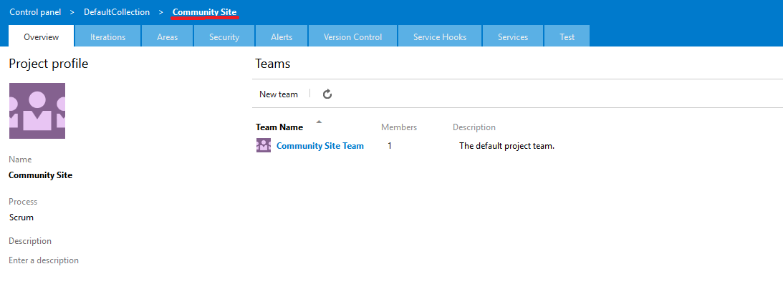

Here you can add multiple teams to a project by clicking on New team. This would be useful in a scenario where you had multiple teams contributing to a project and wanted to keep their backlogs of work separated, or perhaps assign different permissions.

1. Select the **Iterations** tab.

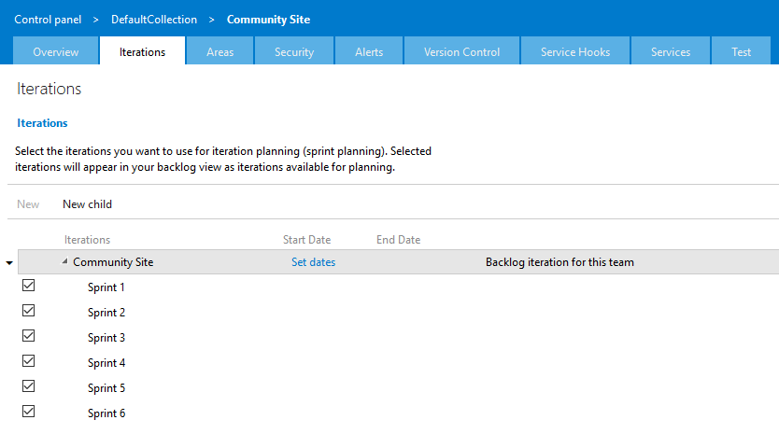

As stated on the web page, these iterations are used during sprint planning for the project and selected iterations will show up on the backlog view. The Scrum methodology is an iterative process that is typically broken up into “smaller” chunks of time. By default, a hierarchy is created that defines a few releases, with a few sprints already defined for the first release.

1. Select the down arrow to the left of the “Sprint 1” iteration to expose the context menu and then select the Open option.

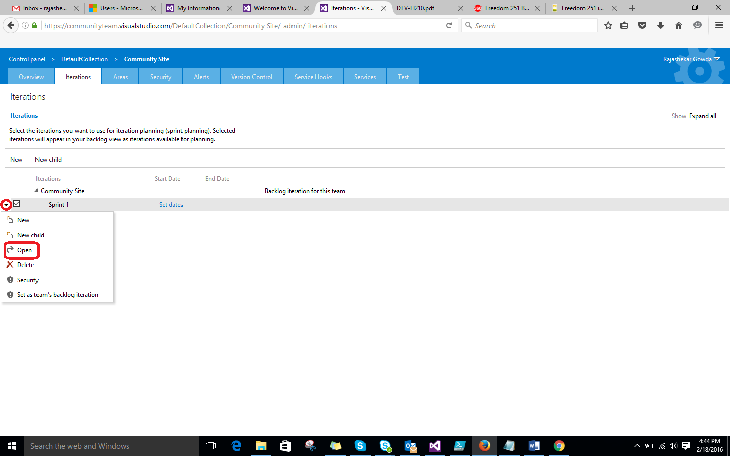

1. Imagine that the team has decided to use 1 week sprints. Although we may typically start a sprint at the beginning of a week, go ahead and assign a start date of today, and an end date four business days later (which are Monday through Friday). Click the Save and Close button.

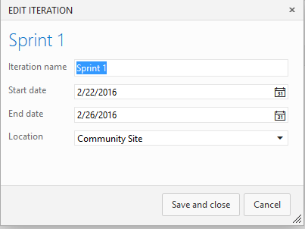

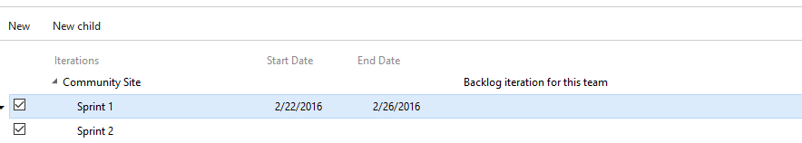

1. Select the **Areas** tab.



1. Area paths and their configuration determines what work will show up on a team backlog. In this simple case, we only have one team and one area defined. If you were to create another team, this would create additional child areas underneath the root “Community Site” area.

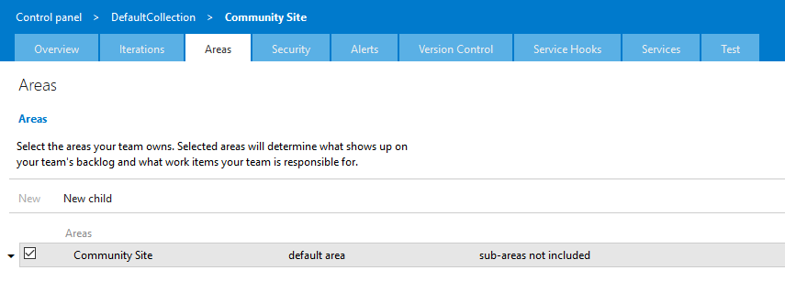

1. Select the **Security** tab.

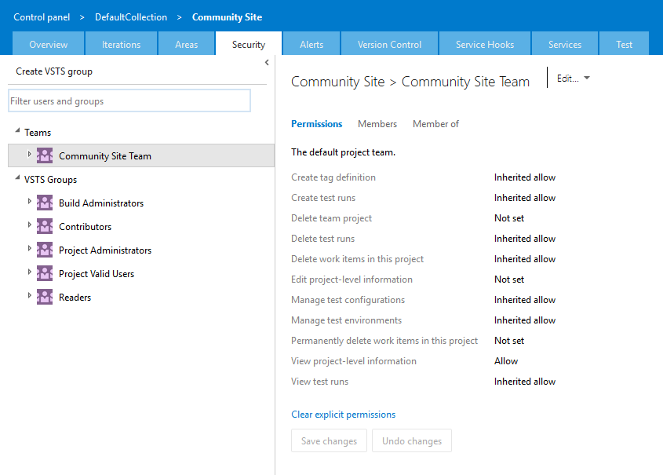

1. You should now be looking at the default security settings for the “Community Site Team” group, which is the default team for the project. Note that members of the team have the permission to create/delete test runs and view project-level information, but not to delete the team project.

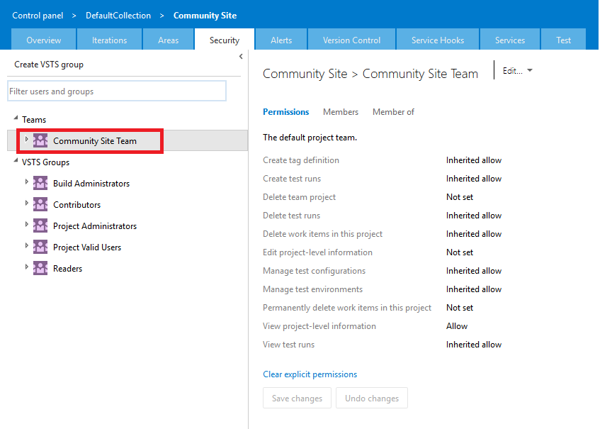

1. This interface makes it easy to understand effective permissions for groups and users. Each permission shows that it is set to some variation of “allowed” or is listed as “not set”. Hold the mouse cursor over the “Create Test Runs” permission and then click on the “Why?” link that appears on the right side.

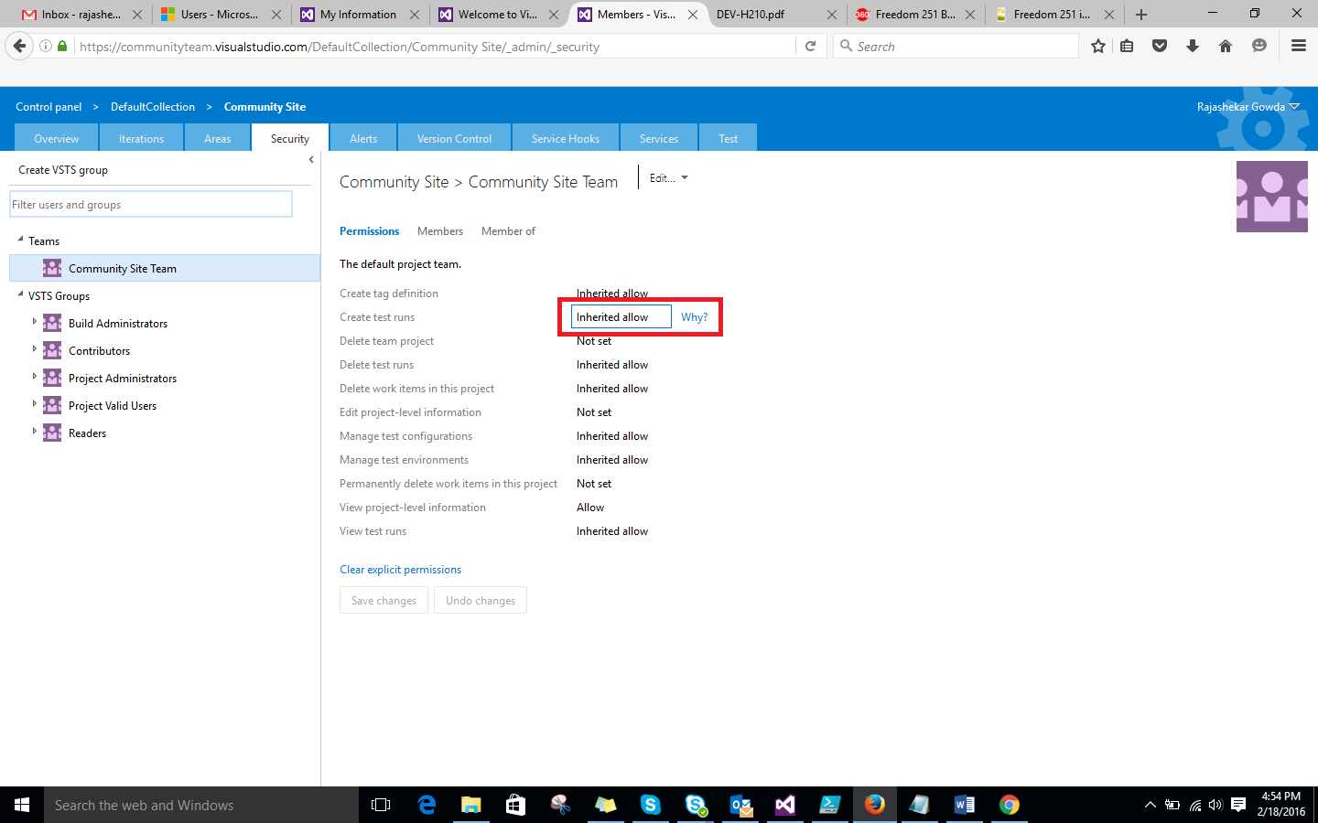

1. Tracing the permission inheritance shows us that Community Site Team members are allowed to create test runs because the security object representing the team is a member of the Contributors group, which explicitly allows this permission.

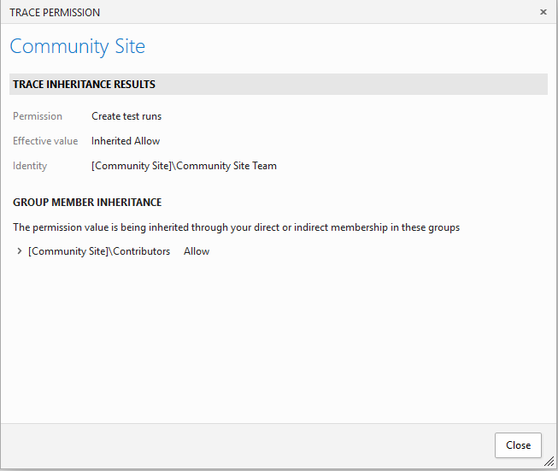

1. Select the Alerts tab.Team members can create and configure alerts to send out notifications for check-ins, code reviews, work items, and builds.

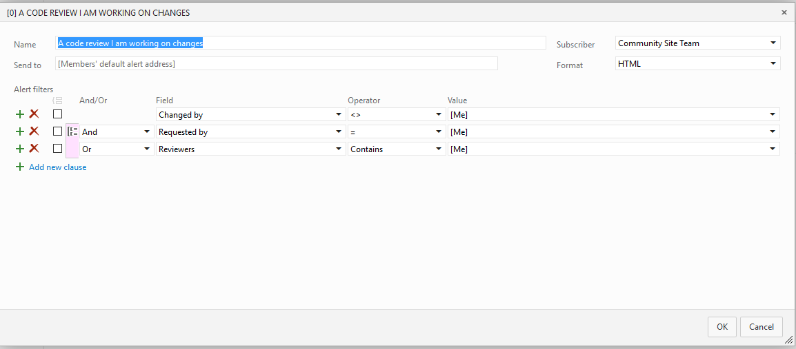

These alerts are highly customizable, as you can see by the definition of the default code review alert that was created for the logged in user. You can add in an arbitrary number of clauses and make use of various logical operators.

1. There are a number of common alert templates that you can use to get started listed in the “Create New Alert When” section. For example, you could setup a team alert (that goes out to members’ default alert address) for the failure of a specific build.

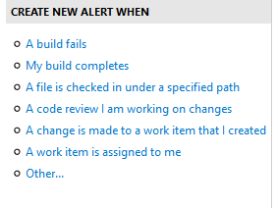

1. Select the Version Control tab. This is where you can view and modify the security of the source control component of the project.

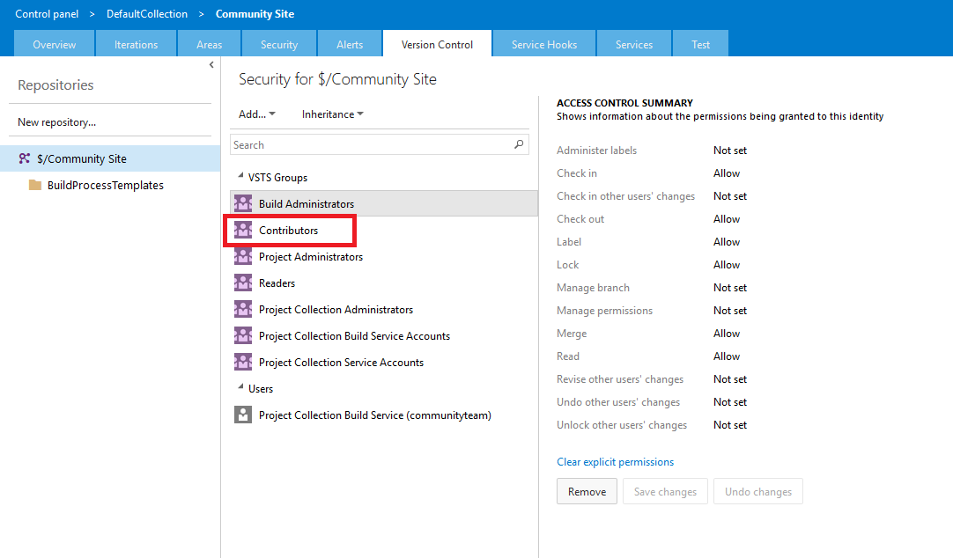

On the left side you can see the source control tree, which allows you to select the root source control node, or something more granular if you so choose. The middle column allows you to select groups or users, and then view/modify the source control permissions on the right. Select the Contributors group to view the default permissions.

1. Close the browser tab to return the project overview page.

**Planning and Execution**

Here you’ll use the Visual Studio Online portal to walk through the creation of a project backlog, estimation of team resource capacity, estimation of effort, and the planning of iterations. Once the project is underway, you’ll learn how to update and view project status using the available tools.

**Creating a Product Backlog**

1. Select the Backlog link from the Work section of the project overview page.

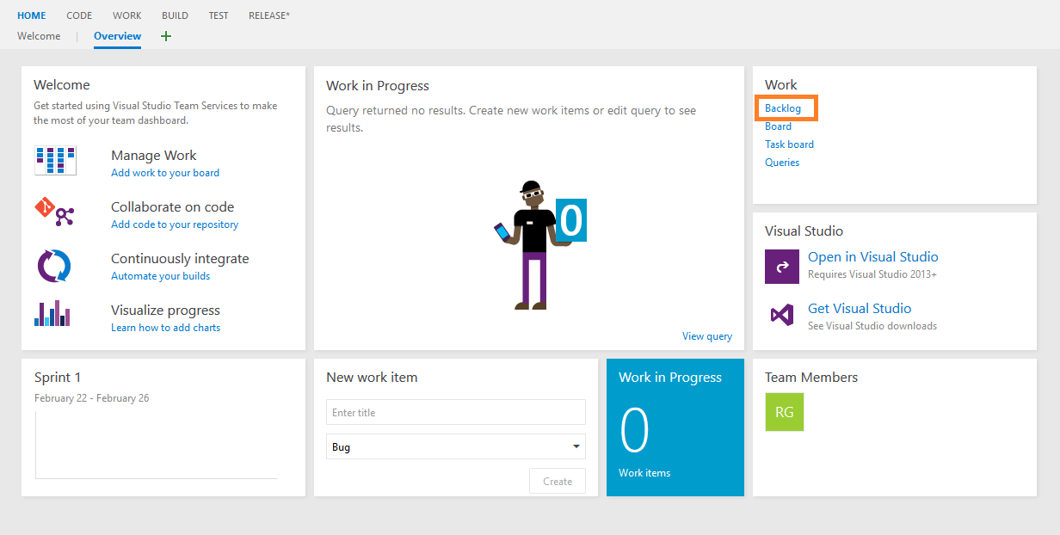

1. The process template that was selected when creating the project determines the types of work items that can be created on the backlog. Create a new Product Backlog Item (PBI) titled “Create database” and then click the Add button.

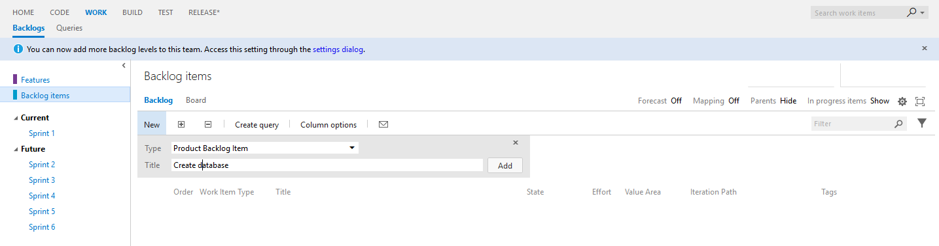

1. Create a second PBI titled “Create new web site”.
2. You can order the backlog items by dragging and dropping them. This can help assign an initial priority that the team can further discuss during future sprint planning. Try dragging the “Create new web site” work item and dropping it just above the “Create database” work item.

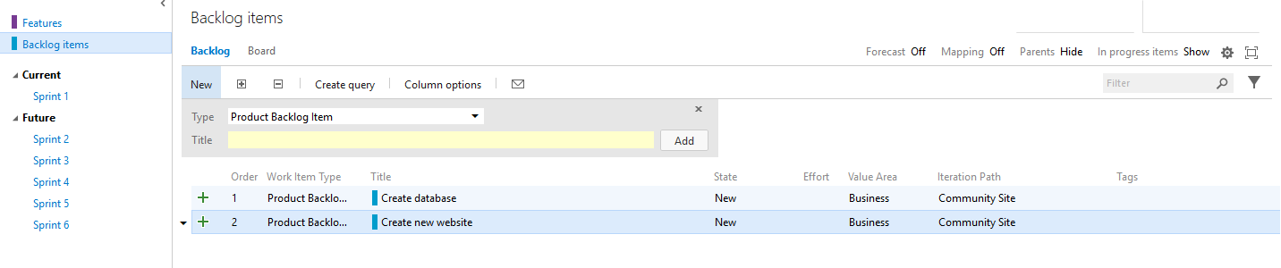

1. Double-click on the “Create new web site” PBI to open it.

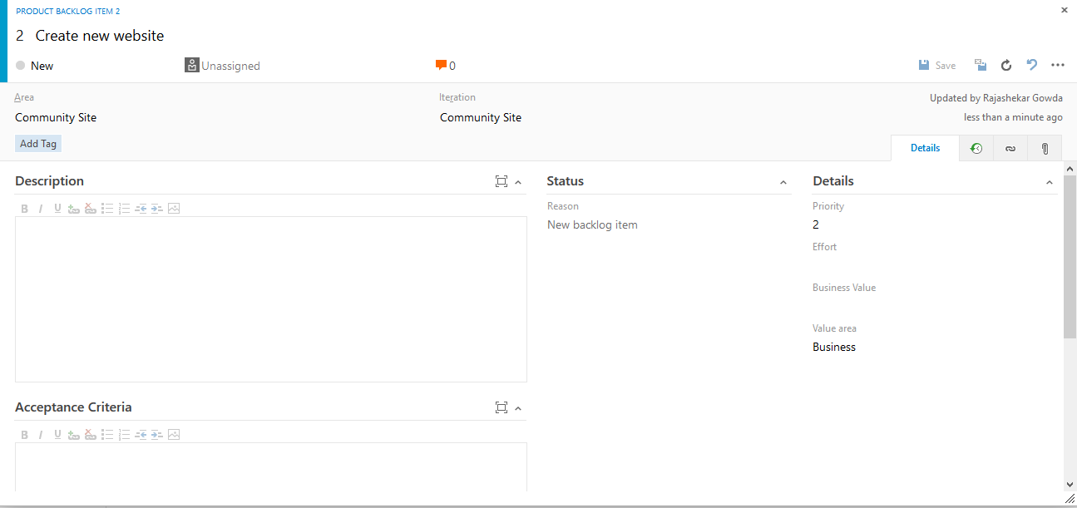

Here you can give the effort, prioritize between multiple backlog items. You can customize as it is required by you.